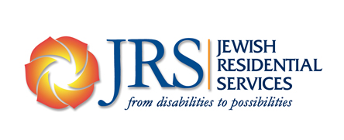

JRS Life & Legacy Case for Support
If you talk to the clients of Jewish Residential Services, who live with psychiatric and/or intellectual disabilities, you’re likely to hear how JRS helped them transition from school-age services into independent living in safe and affordable homes. How it helped them identify and cultivate meaning in their lives, including rewarding work. How it helped them develop a close circle of friends, with whom they enjoy Shabbat dinners and a full calendar of holiday celebrations and observances. How JRS makes it possible to remain close to the synagogues and the JCC—not to mention the movie theater and coffee shops—that are the lifeblood of the community. How they feel secure knowing that JRS will provide this support throughout their lives.

If you visit a law firm, preschool, or any other organization for which JRS clients work or volunteer, you will hear how much these individuals give back to the community. Talk to Squirrel Hill residents at large, and you will hear about JRS’s role in revitalizing the gateway to the community, changing perceptions about people with disabilities, and promoting recognition and appreciation of diversity.

But these contributions are just the beginning. If you talk to the parents of individuals who benefit from JRS programs and services, you’ll hear one story after another how JRS relieves the worry, as they age, of who will care for their child when they are no longer able. How it ensures that individuals with disabilities will always be part of a safe and welcoming community.

If you talk to a member of the JRS staff or board, you will hear about the agency’s slow and steady growth and commitment to making an even greater impact. You will hear about how, despite the unpredictability of public funding, JRS never wavers in providing critical services. How it celebrates and shares Jewish values and traditions with Jews and non-Jews alike. How it benefits people of all backgrounds and identities. How it is committed to ensuring that individuals and families in need will always be able to turn to JRS for support.

Finally, if you talk to individuals who have made legacy gifts to JRS, you will hear about how good it feels to help people live full and connected lives. How rewarding it is to be part of something larger than themselves, something lasting. How satisfying it is to know that these gifts will help JRS realize its mission for many years to come.

Thank you for considering a legacy gift. We and those whose lives we touch deeply appreciate your support.

